[1]

Light-Activated Resins and Their Use in Digital Light Processing Fabrication

Chance W Baker

***Index Terms*— Light-curing Resins, Three Dimensional Printer, Digital Light Process.**

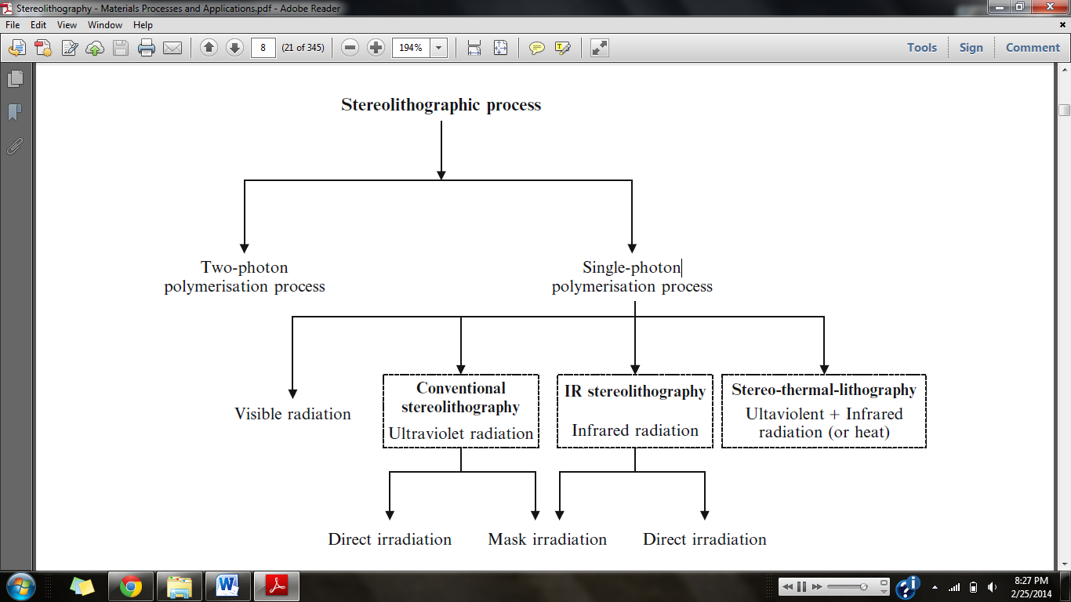

Fig. 1. Flow chart of the Stereolithographic process [1].

# INTRODUCTION

**L**

IGHT-CURING resins is another name for photo-polymerization reactions, light-polymer interactions, or stereolighographic. Stereolighographic is a process that transforms multifunctional prepolymer, *resin,* into a cross-linked polymer [1]. This is done through a chain reaction that is started by reactive species, *cure agents,* generated by light exposure, in most cases UV rays [1].

The first step of light-polymer interaction starts with a photo physical process forcing electrons to begin to move. Photons then have to interact with atoms to promote transitions between the ground state and excited states [1]. P.J. Bàrtolo shows the rest of the process of Stereolithographic in the diagram in Fig. 1.

This process has been recently added to the three-dimensional (3D) printing world known as stereolithography 3D printers (SLA printers). Printers that use resin instead of filament have a higher precision. Filament printers (FDM Printers) have a precision of about 100 microns, while SLA printers can have a higher precision than 1 micron [2].

# Discussion

## The Build Table

In a SLA printer the resin is held in a tub known as a vat. The light source can be located above or below the vat to cure the resin. SLA printers with the light source below the vat print the object from the top to the bottom [3]. This creates the need for the resin to be able to cure to the build table, the table that the object is printed on. This table is moved in and out of the vat. It is placed into the

resin so the resin can be light-cured, then it moves up to allow the vat to refill, and then it repeats.

The B9Creator (B9) uses an aluminum build table attached to a z-axis [3]. When printing small objects, the resin is able to fasten to the aluminum without falling off throughout a build. To increase the adhesiveness of the resin to the table, the B9 has programed the exposer time for the first couple of layers to be increased [3]. This insures that the resin has been completely cured and fastened to the table. This solution works well for small prints that have a small surface area. The effectiveness of increasing cure times to improve adhesiveness goes down as the size of the objects increase [2]. Increasing the cure times can cause resins to shrink [4].

Members of the Build Your Own SLA Printer forum have coated the build table with a sheet of Fluorinated Ethylene Propylene (FEP) [4]. FEP almost doubles the adhesiveness of the resin to the build table [4]. This coating cost approximately $10.00 per 6 in2 [4]. Although this cost is negligible compared to the cost of wasting resin that is sold between $40.00 per liter-$60.00 per liter [3].

## The Vat

Using a project that sits below the vat can cause resin to cure to the vat. This causes the layers to be ripped apart when the build table is moved away from the vat. Several groups have found a way to mend this problem.

The creators of the B9 use a two section vat separated by what they refer to as the *waterfall* [3]. The B9 has a rubber wiper that will squeegee the uncured-resin from the shallow end, over the water fall into the deep end [3]. The wiper allows for the polydimethylsiloxane to be oxygenated preventing the resin to be cured to the vat [3]. Though this only adds a few seconds to each layer, the overall build time is greatly increased due to the number of layers even small objects take to finish.

Another choice is to apply the chemical Sylgard 184 to the vat table which gives an almost perfect non-sticking capability to the vat [4]. Sylgard is a fast dying chemical that can be difficult to apply to the vat and must be applied after a couple thousand layers depending on layer size.

The most common coating applied to the bottom of the vat is Teflon [4]. This is a much easier chemical to work with than Sylgard because it does not dry Sylgard. It is also about thirty percent cheaper and will last twice as long [4]. Teflon leads to two to three times as many builds being ripped apart compared to Sylgard [4].

Several members of the Build Your Own SLA community have tested tilting the vat as the build table moves up [4]. Titling the vat peels the object away from the base instead of ripping it way. This prevents the layer from creating a vacuum to the vat making it difficult to remove safely. This solution adds the cost of another stepper motor and a use of a controller to tilt and reset the vat [4]. Titling is an effective way to prevent tearing prints, but it increases more error in precision because of the extra movement of the vat [4].

Some testing has been done with Gorilla Glass without coating to determine if a non-chemical solution is possible [4]. The glass is attached to a frame on two sides leaving the other two sides to flex while the build table is lifted [4]. When the build table is lifted, the glass will be able to flex and peel away from the cured resin. Fig.2. shows how well the glass flexes, making it an excellent choice for a vat. Gorilla Glass is also a durable material that will remain free of wrinkles, tears, and UV damage [4]. The cost of a 9”x9”x0.031” plane is around $110 [4]. The benefit of this idea is that it is a onetime investment that does not decrease the quality of the prints.

|  |  |  |  |
| --- | --- | --- | --- |
| **Build Table** | | | |
| **Solution** | **Cost** | **Effectiveness** | **Advantage** |
| Aluminum No Coating | No Extra Cost | Low | No Cost |
| Increase Cure Time | Increase Build Time | Medium | Free |
| Coating of FEP | $10.00 per 6 in2 | High | Faster Build Times |

Fig. 3. Comparison Chart of three possible solutions for build tables~~.~~

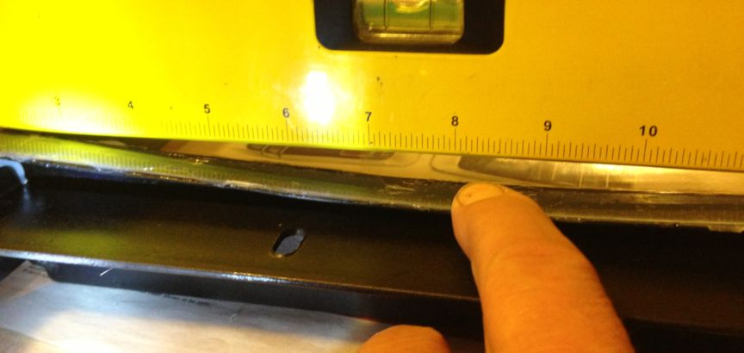

Fig. 2. Gorilla Glass flexing with a small amount of force applied.

# Conclusion

SLA printers have the potential of becoming the highest precision hobbyist printer. With a few modifications that increase the accuracy of successful prints they will over-power FDM printers.

For the build table a possible solution would be to combine some of the different methods that have been done in other printers like the B9. This solution would include making the build table out of aluminum and scoring it to increase the adhesion between the resin and table. Deciding the cure time of the first few layers to be longer can also decrease the chance of having bad prints, and it is cost-free minus adding print time. Fig. 3 is a comparison of the three choices that are commonly used.

For any printer using a projector or laser under the printed object, the vat plays a major part of the quality of prints. The Gorilla Glass offers a one-time-buy solution that will last for the printer’s life. This solution is the cheapest option if the user plans to print objects frequently. Fig. 5 shows a comparison of five existing options for vat designs.

# References

1. IM. Tehfe, F. Louradour, J. Lalevèe and J. Fouassier, Photopolymerization Reactions: On the Way to a Green and Sustainable Chemistry, 1 ed. , from Institut de Science des Matériaux de Mulhouse: 28 March 2013.
2. I3XL-PRUSA I3 9X12X7, “DIY Techshop,” [online] January 2014, shop.diytechshop.com (Accessed: 20 February 2014).
3. Getting Started, “B9Creator,” [online] 2013, b9creator.com (Accessed: 23 February 2014).
4. Print Not Sticking to Build Plate, “Build Your Own SLA,” [online] January 2014, www.buildyourownsla.com (Accessed: 26 February 2014.

# Appendix



Fig. 4. House of Quality for the different surfaces of the build table.



Fig. 6. House of Quality for the different vat materials, set-ups, and coatings.

|  |  |  |  |
| --- | --- | --- | --- |
| **The Vat** | | | |
| **Solution** | **Cost** | **Effectiveness** | **Advantage** |
| Squeegee | Motor and Time | High | Level Layers |
| Sylgard 184 | $60 0.5 kg | High | Non Stick Surface |
| Teflon | $14 10 oz. | Med | Cheap and Easy to Use |
| Tilting | Motor and Time | Med | Peels |
| Gorilla Glass | 9"x9" $110 | High | Peels w/o movement |

Fig. 5. Comparison Chart of five possible solutions for the vat.

1.